

**Alien Hop**

**Thank you for purchasing the asset , if you have any question please contact me at** [**madfireongames@gmail.com**](mailto:madfireongames@gmail.com)

**Project Structure**

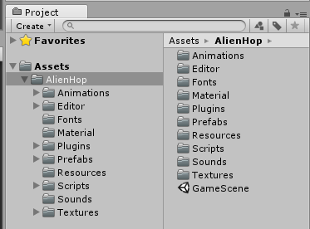

**Animations folder**: There is stored animations used in game.

**Editor Folder**: There is stored Game Design window script (Dont edit anytging in this folder).

**Fonts folder**: There is stored fonts used in GameScene.

**Textures**: There is stored all sprites and textures used in game.

**Materials:** There is store material of GameObjects used in game.

**Prefabs Folder**: There is stored Game Objects spawned in game.

**Resources Folder**: There is stored resources for Game Design (Dont edit anytging in this folder).

**Scripts Folder**: There is stored Script files used in game.

**Sounds Folder**: There is stored Musics and Sound effects used in game.

**Scripts**

1. GameManager:- This script controls the game , its saves and loads data from the device eg:- Best Score , musics status ,etc.

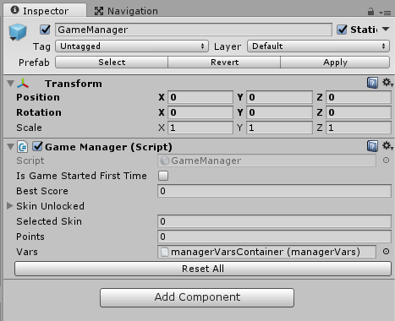

1. Leaderboard:- Scripts which control leaderboard of play store and app store.

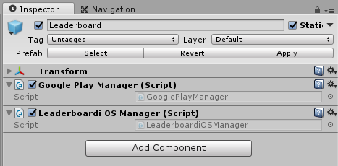

1. Unity IAP:- This script controls the Unity IAP for android and iOS. It controls the remove ads function.

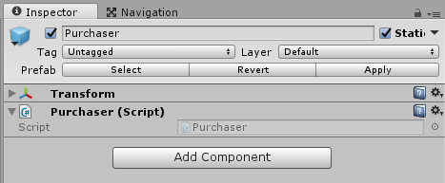

1. ScreenShot:- This script helps player to take the screen shot of their game and share it on the social platforms like facebook , whatsapp , etc.

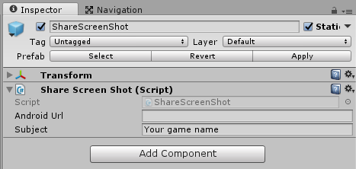

1. GameUI:- This script controls the game menu , is assigns the functions to the buttons and updates the text like score , best score , etc;

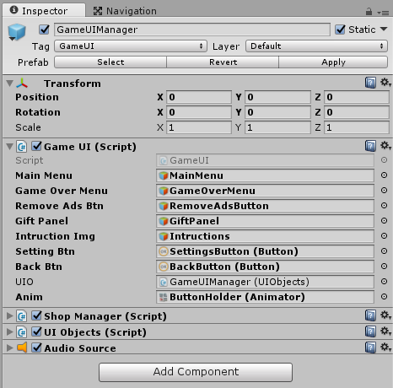

1. ShopManager:- This script controls the shop menu , is assigns the functions to the buttons and updates the character , etc.

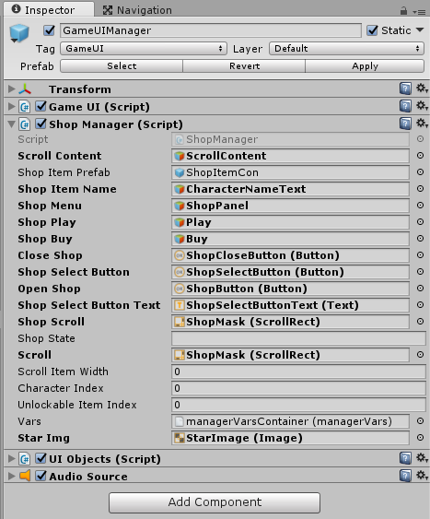

1. UIObject:- This script keep tack of all the elements in the scene like sprites , text , sound , font etc .

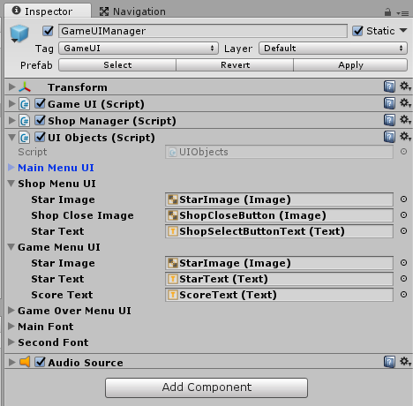

1. EnemyLevelSpawner:- This script controls the spawning of enemyLevels and much more.

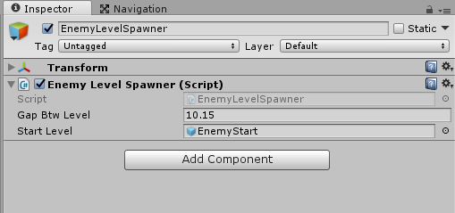

1. ObjectPooling:- This script created the required clone of objects which are used again and again and it the make them active when required , helps in game optimization.

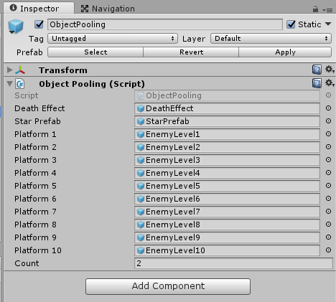

How To Reskin?

Go to Editor -> Click on GameDesign.

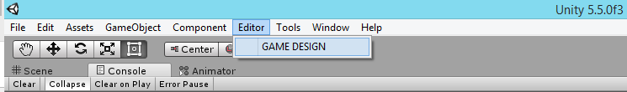

GameDesign window will open.

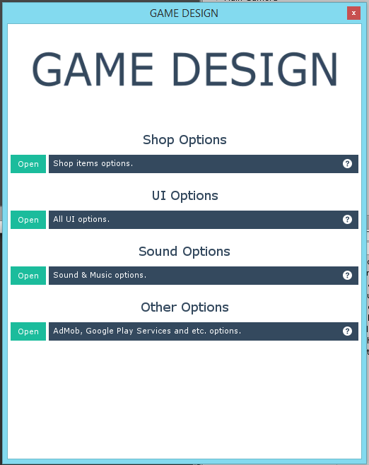

Open any section and you will find fields to change.

**Game Design: UI Options**

You can easily edit all UI Elements like Button sprites, Text colors.

All available configurations is listed bellow:

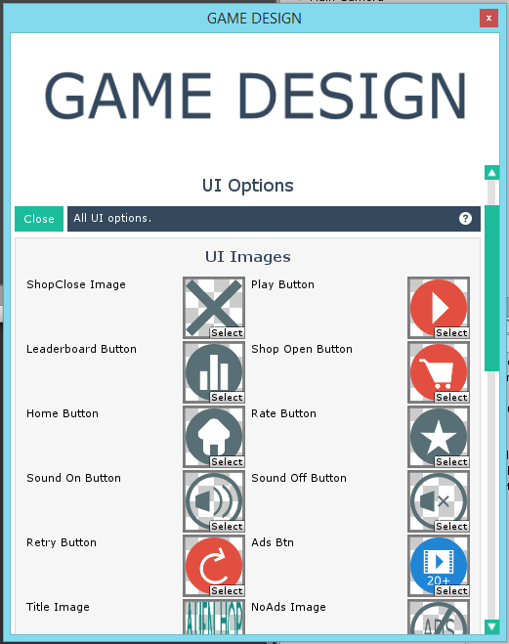

**Game Design: Sound Options / Other Options**

You can easily edit all sounds and musics like characters sound effects, buttons click , admob settings , Leaderboard for iOS and Android , and much more.

All available configurations is listed bellow:

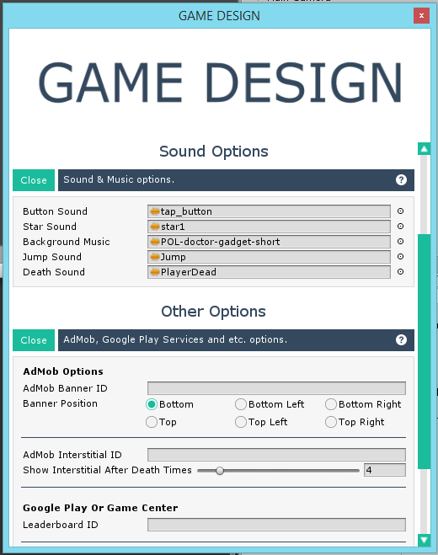

**Game Design: Shop Options**

You can easily add or remove the character by editing the shop options. The shop menu is update by its own , and the character in game also get updated you have to do nothing

All available configurations is listed bellow:

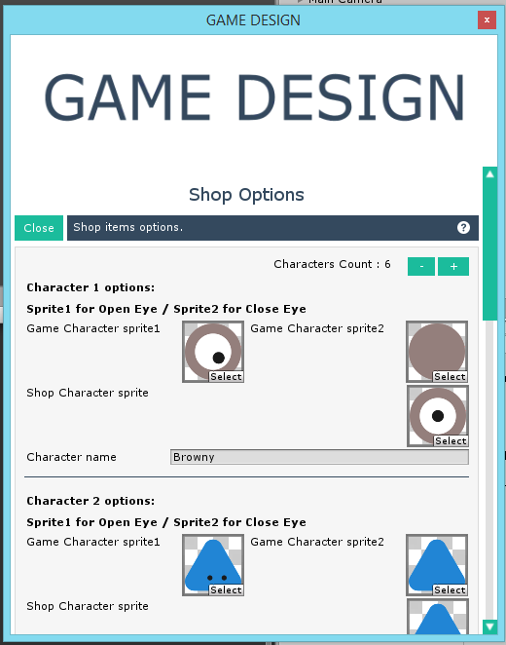

The only thing which you cannot change from here is the sprites of enemies and platform , you will have to do it manually.

**Want Free Assets?**

**Thank you for purchasing my asset , well we have started our own website where we upload free asset every month. So if you are interested in free asset then check out our site and subscribe to the updates so we can contact you on release of new free asset.**

**Link:- https://madfireongames.com/**